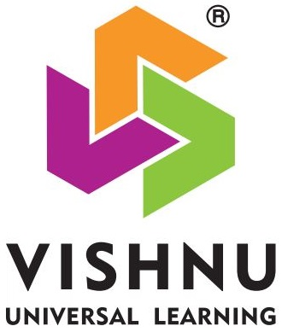**VISHNU INSTITUTE OF TECHNOLOGY: BHIMAVARAM**

**(Autonomous)**

**Approved by AICTE, Accredited by NAAC- A++ , NBA & Affiliated to JNTUK, Kakinada**

**Department of Basic Science**

**Syllabus: II B. Tech- I Semester**

**(R-23 Regulations)**

**(Common to IT, AI&ML, AI&DS)**

**Course Title: OPTIMIZATION TECHNIQUES**

**L T P C**

**3 0 0 3**

**Course Objectives:**

* To define an objective function and constraint functions in terms of design variables, and then state the optimization problem.
* To state single variable and multi variable optimization problems, without and with constraints.
* To explain linear programming technique to an optimization problem, define slack and surplus variables, by using Simplex method.
* To state transportation and assignment problem as a linear programming problem to determine Simplex method.
* To study and explain nonlinear programming techniques, unconstrained or constrained, and define exterior and interior penalty functions for optimization problems.

**UNIT – I: Introduction and Classical Optimization Techniques**

Statement of an Optimization problem, design vector, design constraints, constraint surface, objective function, objective function surfaces, classification of Optimization problems.

**Classical Optimization Techniques**: Single variable Optimization, multi variable Optimization without constraints, necessary and sufficient conditions for minimum/maximum, multivariable Optimization with equality constraints. Solution by method of Lagrange multipliers, multivariable Optimization with inequality constraints, Kuhn – Tucker conditions

**UNIT – II: Linear Programming**

Standard form of a linear programming problem, geometry of linear programming problems, definitions and theorems, solution of a system of linear simultaneous equations, pivotal reduction of a general system of equations, motivation to the simplex method, simplex algorithm.

**UNIT – III: Transportation Problem**

Finding initial basic feasible solution by north – west corner rule, least cost method and Vogel’s approximation method, testing for optimality of balanced transportation problems, Special cases in transportation problem.

**UNIT – IV: Nonlinear Programming**

Unconstrained cases, One – dimensional minimization methods: Classification, Fibonacci method, Univariate method, steepest descent method. Constrained cases– Characteristics of a constrained problem, Classification, Basic approach of Penalty Function method, Basic approaches of Interior and Exterior penalty function methods.

**UNIT – V: Dynamic Programming**

Dynamic programming multistage decision processes, types, concept of sub optimization and the principle of optimality, computational procedure in dynamic programming, examples illustrating the calculus method of solution, examples illustrating the tabular method of solution.

**Text Books:**

1. **S. S. Rao,** “Engineering optimization: Theory and practice”, 3rd Edition, New Age International (P) Limited, 1998.
2. **H.S. Kasene & K.D. Kumar**, “Introductory Operations Research”, Springer (India), Pvt. LTd.

**Reference Books:**

1. **K.V. Mital and C. Mohan**, “Optimization Methods in Operations Research and systems Analysis”, New Age International (P) Limited, Publishers, 3rd edition, 1996.
2. **Dr. S. D. Sharma**, Operations Research, Kedarnath, Ramnath& Co

**Course Outcomes:** At the end of the course, the student will be able to

CO1: State and formulate the optimization problem, , by using decision variables from an engineering problem.

CO2: Apply classical optimization techniques to minimize or maximize a multi-variable objective

functionto arrive an optimal solution

CO3: Apply and Solve transportation and assignment problem by using Linear programming

method.

CO4: Apply gradient and non-gradient methods to nonlinear optimization problems to derive the optimal solutions

CO5: Formulate and apply Dynamic programming techniques to various engineering problems